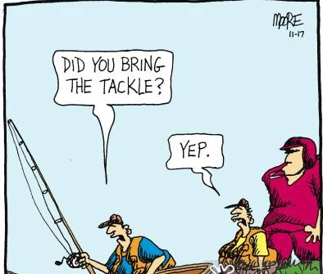TACKLE a Cartoon

**Time** – This is the beginning of setting up the contextualization of the cartoon.

When was the cartoon drawn?

When did the cartoon’s content occur?

**Audience** – By whom is this cartoon intended to be viewed? Think about the people, groups, locations that may view this cartoon and how they may perceive it.

**Context** – What was happening during the time the cartoon was drawn?

What was happening during the time the cartoon is about?

What is in the background of the cartoon?

**Key action** – What is taking place in the cartoon?

What are the characters doing?

What is happening in the background?

**Label or caption** – What does the label or caption mean?

Does it match the action inside the drawing?

What insights into the author’s point of view does this comparison provide (look for irony, satire, sarcasm).

**Expanded purpose** – Why do you think the cartoonist created the cartoon?

What larger issue might have been involved?

Make one or more inferences.